Electrical meter installation verification form

Instructions
- The installation contractor shall complete this verification form for all electrical metering installations, then send it to the University of Toronto project manager, in .PDF format, for F&S Electrical Utilities review.
- Each meter in the contract shall have photos provided as described on page 3.
- Where contractor is responsible for installing communication cabling, the contractor shall complete the following forms, located on the F&S design standards and project forms webpage, and submit to the University of Toronto project manager:
  - F&S network – IP address request form
  - Wiring installation qualification form as described under section 3.19.3 wiring installation qualification document in the building automation systems design standard
  - Provide LINKWARE Fluke reports for each cable installed, as per section 3.19.4 Fluke reports requirements in the building automation systems design standard
- F&S Electrical Utilities is required to sign off this form for the project to be considered completed.

Project information
Project name:
Contractor company name:
Building name and number:

The section below is for U of T to complete
F&S Utilities sign-off (do not proceed with this section unless the image boxes below have been filled)

Project manager (printed):

F&S Utilities engineer name (printed):

F&S Utilities engineer signature:

Date:

Meter summary page
Meter ID | Meter make | Meter model | Meter serial no. | Location (room) | IP address | Gateway | Subnet mask | Description
001-MET-MAIN | Schneider Electric | PM8000 | 645420034 | 251 | 172.17.131.62 | 172.17.131.1 | 255.255.255.128 | Building #001 Main Meter
Date of install: 2024-11-12 |  | Room number: 251 |  |  | Meter ID: 001-MET-MAIN
CTs Installed on bus/feeder  Must show direction of install  If multi-circuit meter, show all CTs. | CT Nameplate (Make, Model, and Ratio visible)  If multi-circuit meter, take picture of each CT nameplate |  | Photo of PTs and/or CPTs (if applicable) | Photo of installed finger-safe fuses for PTs and/or CPTs |  | Photo of the front of meter’s default screen & FT switches
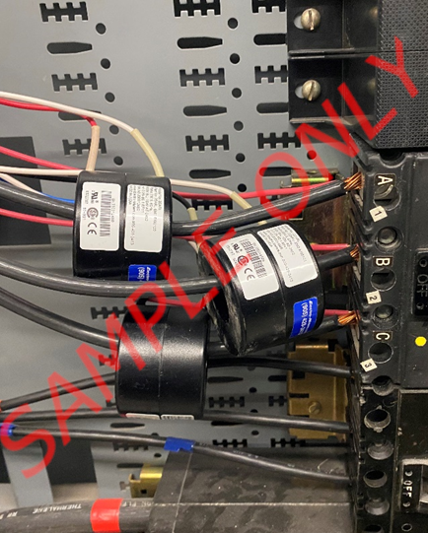 | 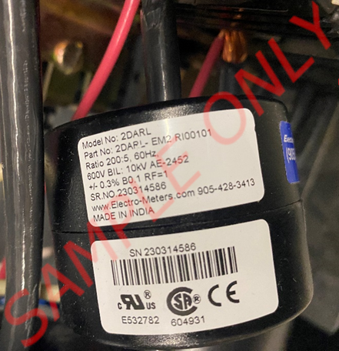 |  | 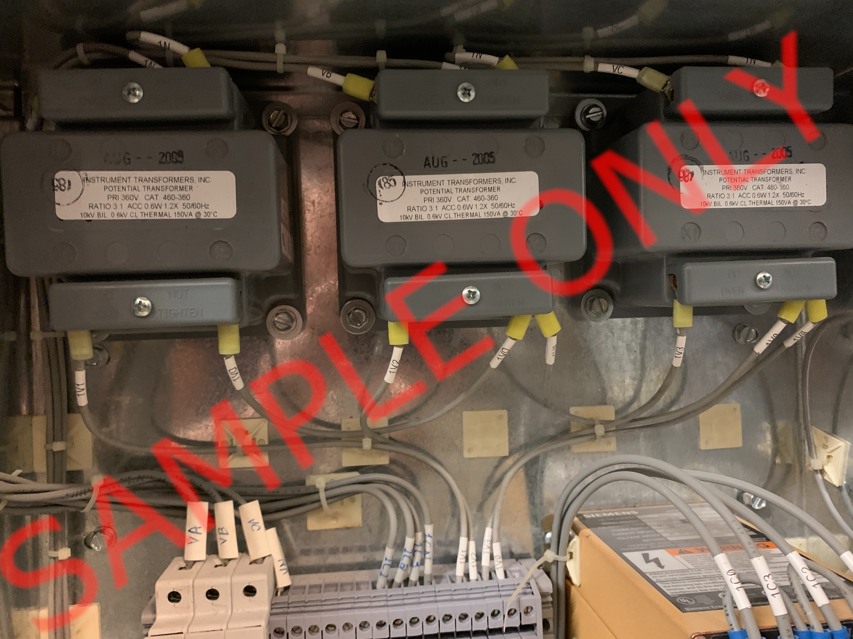 | 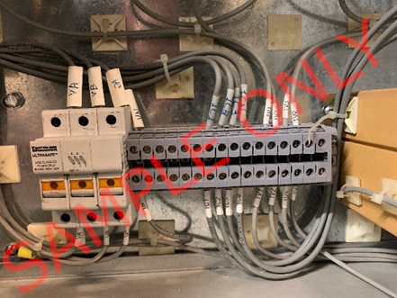 |  | 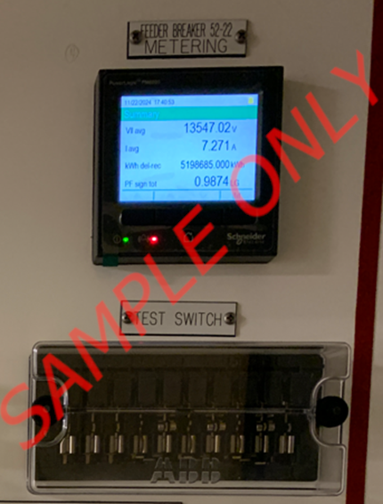
Photo of meter nameplate | Photo of green Cat6 patch cable from keystone box to meter |  | Photo of meter IP address settings (IPv4 Address, Gateway and Subnet Mask visible) | Photo of meter phasor diagram |  | Picture of CT & VT/PT settings on the meter
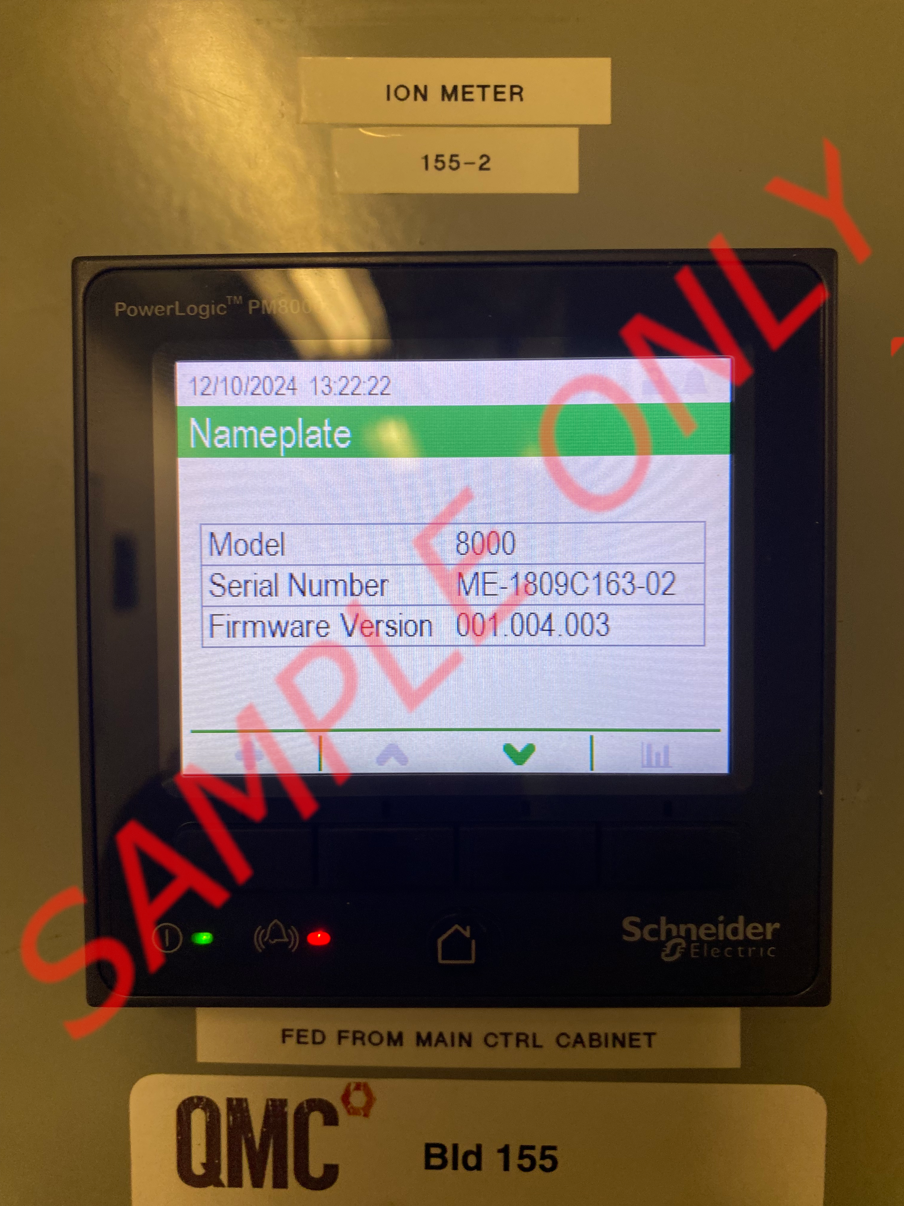 | 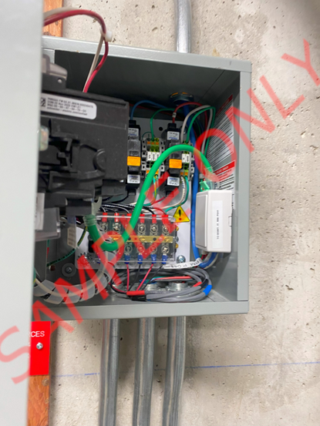 |  | 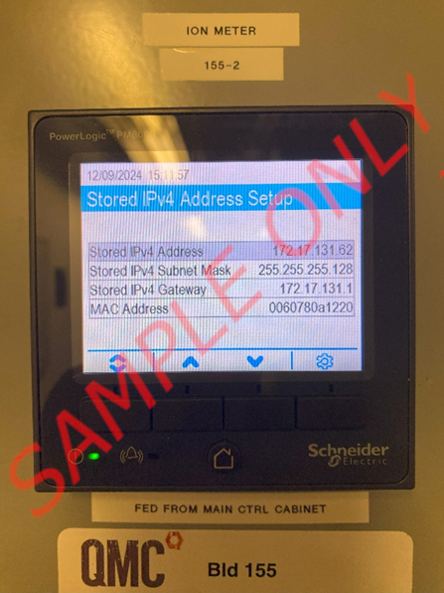 | 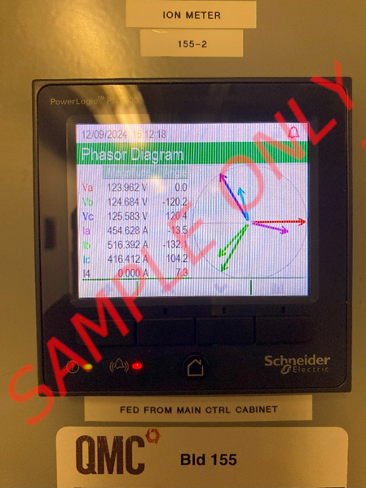 |  | 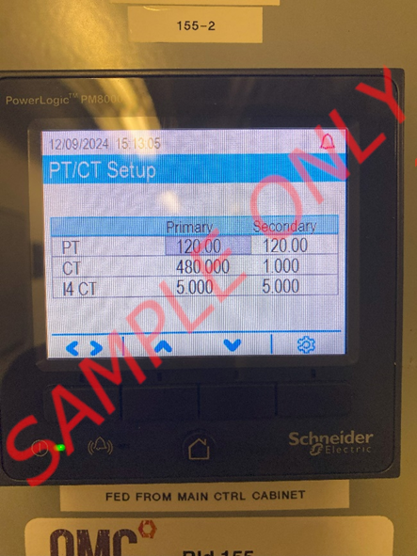

DATE OF INSTALL: [DATE OF INSTALL] |  | ROOM NUMBER: [Room Number] |  |  | METER ID: [Meter Name/ID]
CTs Installed on bus/feeder  Must show direction of install  If multi-circuit meter, show all CTs. | CT Nameplate (Make, Model, and Ratio visible)  If multi-circuit meter, take picture of each CT nameplate |  | Photo of PTs and/or CPTs (if applicable) | Photo of installed finger-safe fuses for PTs and/or CPTs |  | Photo of the front of meter’s default screen & FT switches
Photo of meter nameplate | Photo of green Cat6 patch cable from keystone box to meter |  | Photo of meter IP address settings (IPv4 Address, Gateway and Subnet Mask visible) | Photo of meter phasor diagram |  | Picture of CT & VT/PT settings on the meter

