Wiring installation qualification form – template for B-BC controllers (ETHERNET Interface only)

Important note:
The content of all the screenshots must be easily readable. Failure to provide properly captured and easy-to-read screenshots will result in a delay in the approval process.

Device name | Fluke report cable ID | Digital picture(s) of the device with the wall module  Label: | Digital picture(s) of the device cable label  Label: | Digital picture(s) of the patch panel module  Label: | Digital picture(s) of the patch panel cable label  Label: | Date and initials
EXAMPLE: 070_DDC03 | 070_DDC03 | 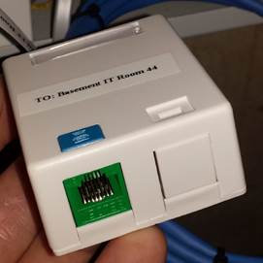  Label: TO: Basement IT Room 44 | 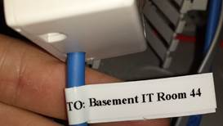  Label: TO: Basement IT Room 44 | 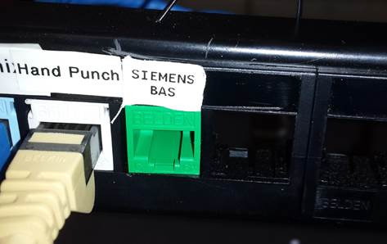  Label: SIEMENS BAS | 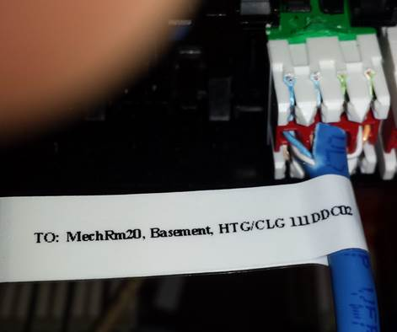  Label: TO: Mech Rm20, Basement, HTG/CLG 111DDC02 | 01-MAR-2017, JS

